You are given an m x n integer matrix grid containing **distinct** positive integers.

You have to replace each integer in the matrix with a positive integer satisfying the following conditions:

* The **relative** order of every two elements that are in the same row or column should stay the **same** after the replacements.
* The **maximum** number in the matrix after the replacements should be as **small** as possible.

The relative order stays the same if for all pairs of elements in the original matrix such that grid[r1][c1] > grid[r2][c2] where either r1 == r2 or c1 == c2, then it must be true that grid[r1][c1] > grid[r2][c2] after the replacements.

For example, if grid = [[2, 4, 5], [7, 3, 9]] then a good replacement could be either grid = [[1, 2, 3], [2, 1, 4]] or grid = [[1, 2, 3], [3, 1, 4]].

Return *the****resulting****matrix.* If there are multiple answers, return **any** of them.

**Example 1:**

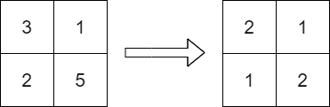

**Input:** grid = [[3,1],[2,5]]

**Output:** [[2,1],[1,2]]

**Explanation:** The above diagram shows a valid replacement.

The maximum number in the matrix is 2. It can be shown that no smaller value can be obtained.

**Example 2:**

**Input:** grid = [[10]]

**Output:** [[1]]

**Explanation:** We replace the only number in the matrix with 1.

**Constraints:**

* m == grid.length
* n == grid[i].length
* 1 <= m, n <= 1000
* 1 <= m * n <= 105
* 1 <= grid[i][j] <= 109
* grid consists of distinct integers.